**Home page**

1. Home page top view contain Major KPI given by Client

* Revenue
* Total Bookings
* Average Rating **( using Gauge chart)**
* Total Capacity
* Total Succesful bookings
* Occupancy %
* Total Cancelled Bookings
* Cancellation Rate

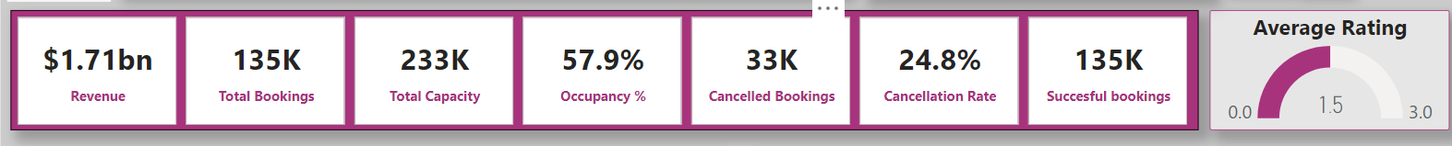

2.User can select Month from top slicer bar , which contain **JULY,JUNE,MAY** as filter

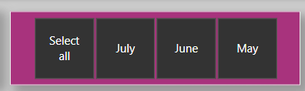

3.Two navigator button has been provided

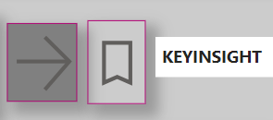

: Navigation link for Top/worst hotel dashboard

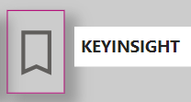Navigation link for KEY INSIGHT dashboard

4.By selecting Month (In slicer )user can check blow mention graph:

=> weekly Trend (revenue and rating) using **Line Chart**

=> %share of revenue among Hotels in **Donut Chart**

=> **Table matric** for Hotel vs all import KPI

=> Avg Rating of user for City and Room type in term of **Bar chart**

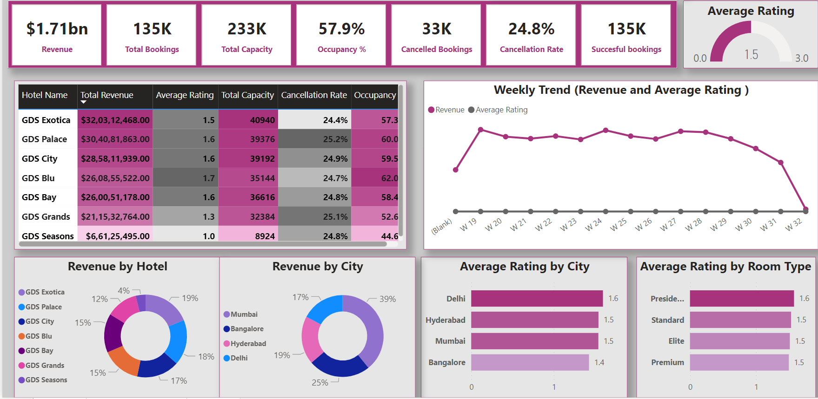

**Top/Worst dashboard**

1.By Clicking  user will navigate to Top/worst dashboard

2.User can select Month from top slicer bar , which contain JULY,JUNE,MAY as filter



3.User can select City with Top/Down **Slice Bar**

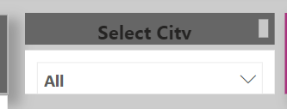

4. 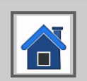 Home button top left corner given to go back to **Home page**

5. Post Select City or Month, user can analysis **Top/worst Hotel in** term of **REVENUE/CAPACITY/OCCUPANCY/CANCELLATION RATE** by using **Bars charts**

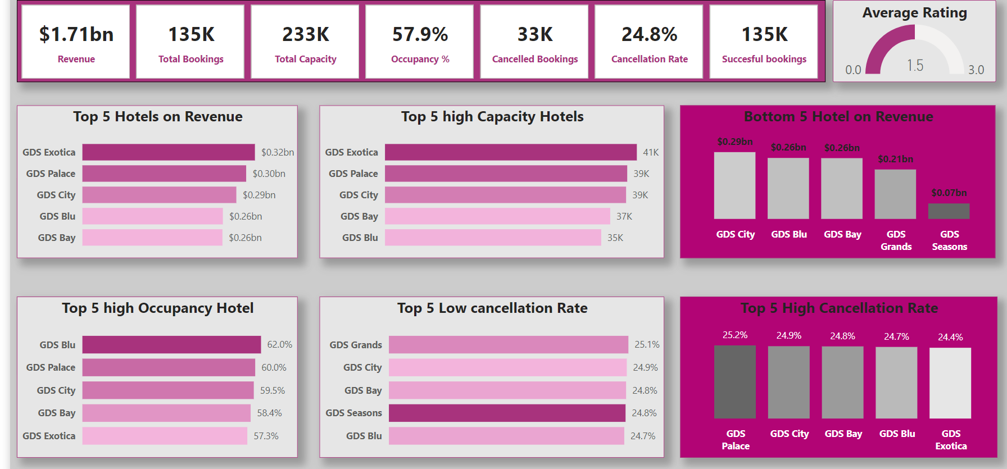

**Key Insight**

1. Final highlight of total analysis has been given in term of dashboard

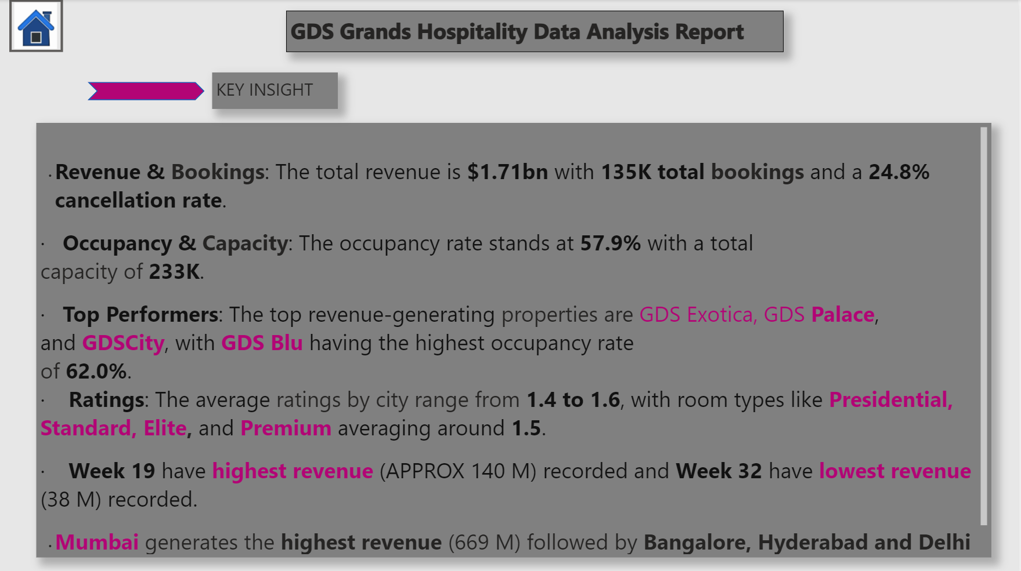

2).  Home button top left corner given to go back to **Home page**